LITRACY INDIA community COLLage (LICC)

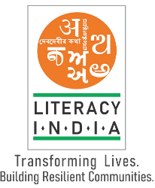**PROGRAM OFFERED**

## .ROBOTIC / TINKERING

## .BEAUTY & WELLNESS

## .STITCHIG & CUTTING

## .ELECTRICAL TROUBLESHOOTING

## .TWO-WHEELER REPAIRING

## .MOBILE JOURNALISM

## .COMPUTER HARDWARE

## .MOBILE REPAIRING

## .COOKING / HOSPITALITY

## .COMPUTER SCIENCE

## .call centre/ bpo

## .LOGISTIC

## .DATA DIGITIZATION

## .NATURAL FARMING MARKET CONNECT

**.**BANKING